|  |  |
| --- | --- |
|  | TELUS Domain Context Purpose of the Domain Context:  To define the bounded context and define the entities in each   * Anchor the entities to the domain context * Related to function, processes, applications     The TELUS Domain context provides   * Domain context to function mapping * APIs and entities of the domain context   For each API and each Entity the domain context describes the business context   * What is the scope of the API * When should it be used * Intersection of entities   The domain contexts were determined by first creating the the domains in order to define the bounded context   * Input into the context was taken from the eTOM business processes however it is important to understand the domain contexts are not equal to the eTOM business processes * Once the domain contexts are established the entities within are defined * The entities are then used to define the microservices * The microservices specifications are defined by the Open API specifications |

# Domain Context Specialization

Domain context specialization recognizes that within a domain there may be a need for a specialization of the context. Business context is by definition within a domain. In Party for example we consider Supplier as a context. We can then specialize within the context. Within a domain context specialization you can extend but also remove properties in the generic context but still remain within the domain context.

# TM Forum Open API Map

The TM Forum Frameworx references and descriptions have been used to determine the correct placement of the TELUS portfolios within the domain map. Defining which domain a portfolio’s systems belong to is a step towards placing the portfolio in the applicable bounded context. Setting the domain boundaries provides the ability to identify the logical services related to a domain. Logical services are used to map to the APIs which realize the capabilities of a domain. By placing the portfolios within a domain it can be determined which logical services relate to the domain. Once determined the TM Forum Open API Map can be used to determine the applicable APIs.

# TELUS Domain Context Map

Applying Domain Driven Design, TELUS has created a Domain Context Map. The Domain Context Map is based on the Frameworxs domains but further decomposes these large domains in more granular domains and subdomain contexts in order to provide a clear and concise context and scope of responsibility for APIs. The Domain Context Map aligns the context to a business capability, TM Forum Open API specification and includes the context binding (Microservice and schema) and the domain context events that should be implemented to realize the capability. The Domain Context Map ‘maps’ between logical business capability and the physical implementation of an API.

Adopting the Domain Context Map across the Enterprise will align APIs with the Enterprise portfolios and Enterprise data management.

The following additional terms to the Domain Driven Design terms are used within the TELUS Domain Context Map. Their definitions are included in this section for easy reference.

Definitions:

A Capability (a.k.a Business Capability) represents and defines an ability that an actor (e.g. resource, organization, person, system, etc.) possesses or wishes to possess.

* Capabilities focus on business outcomes and provide a high-level strategic planning view of current and desired abilities of an organization in relation to its strategy and environment.
* Capabilities are definitions of abilities that are expressed in general and high-level terms - they do not perform activities, rather they realized by a combination of actors (e.g. organizations, people, processes, information, technology, etc.)
* Capabilities can be categorized as:
* Strategic (direction-setting of business itself)
* Customer-Facing (a.k.a. Core / Commercial)
* Supporting (supports all other Capabilities)

A Domain represents a realm or range of knowledge, responsibility, field of action, thought, influence, etc.

* A Domain is a general concept that needs to be qualified for clarity.
* Examples of Domains include:
* Architecture Domains (typically expressed as layers)
* Business Domains (e.g. TM Forum Frameworx)
* Capabilities are definitions of abilities that are expressed in general and high-level terms - they do not perform activities, rather they realized by a combination of actors (e.g. organizations, people, processes, information, technology, etc.)

Domain Context Map

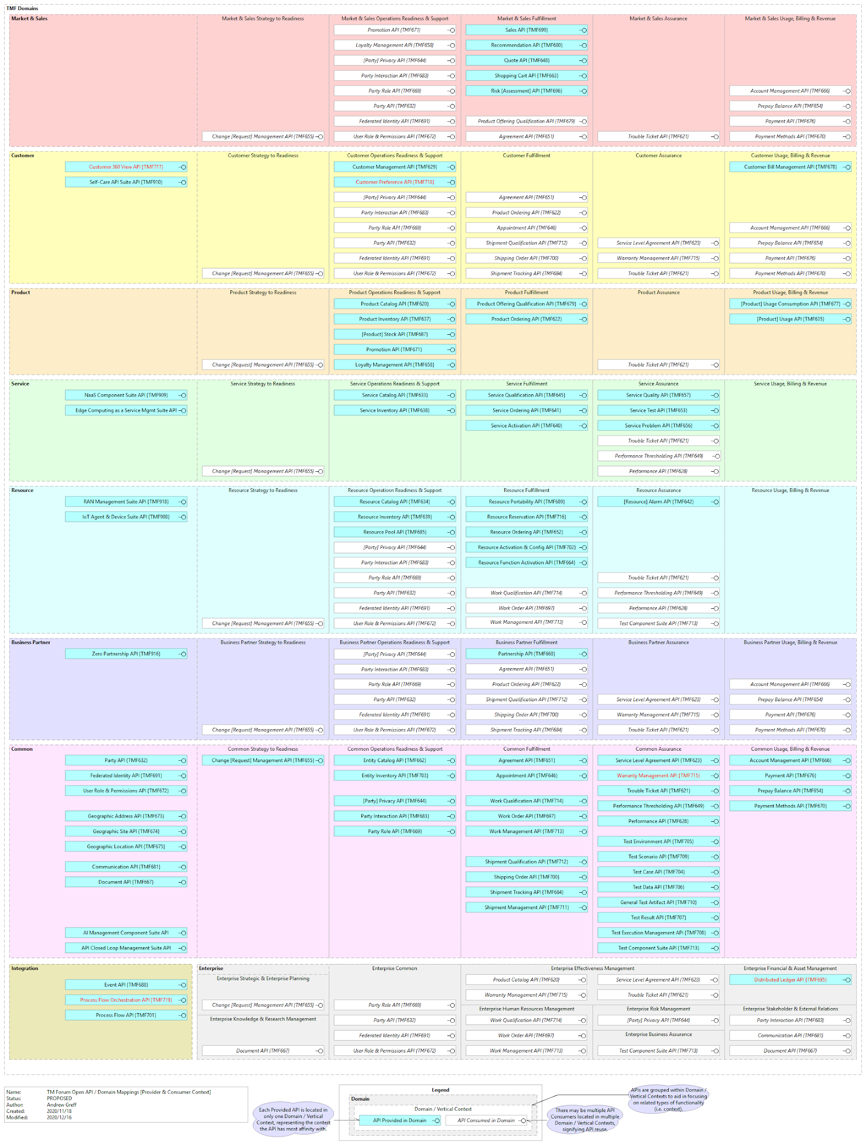

[Telus Domain](https://docs.google.com/document/d/1tc_1Xhxg4NVouuhzmdelcQB2mmyCVCDAKNaRyX2CZ_I/edit#heading=h.cs4or9kwvzn7)

# TELUS Domain Context Map